Programme Design Record (PDR)
Notes for Pilot programme teams:
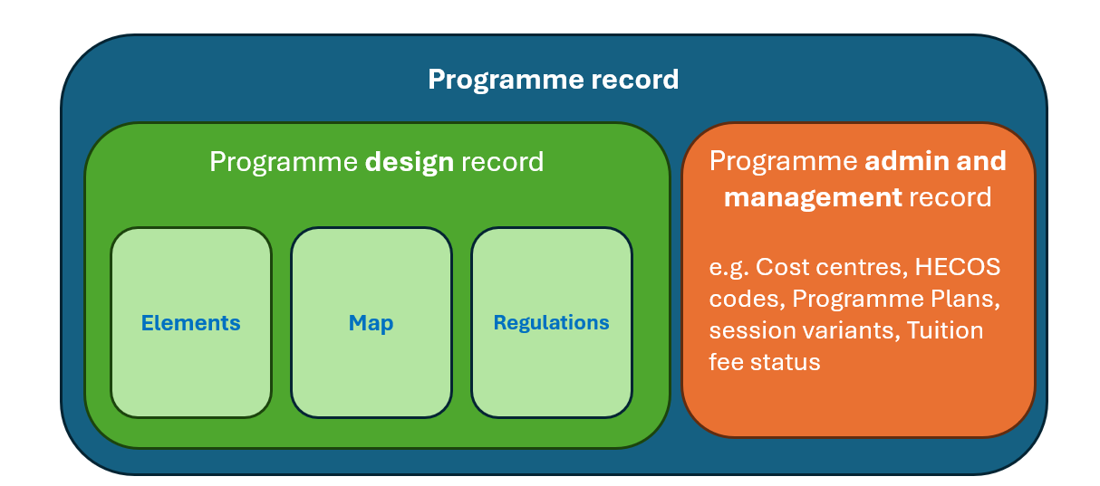
The purpose of the PDR is to document the key educational features of a programme, forming the definitive curriculum design record of the programme. This provides information for current students as the key document describing their programme. therefore, this should be written in student-facing language and elements will be used for marketing.
The new PDR replaces the existing Programme Specifications and incorporates Programme Regulations. In future this information will be captured in the new Curriculum Management System (CMS), but for now it will be captured on Word and Excel templates. This new approach is being piloted as part of the Leading Edge Curriculum (LEC) Phase 1 and so we welcome feedback from pilot teams.
A PDR should be completed for each programme that has a distinct set of Programme Learning Outcomes – this may cover several programme titles as programme regulations currently do (e.g. XXX with placement). But if there are variations in PLOs these should prompt a separate PDR – even if some of the content is duplicated across PDR where elements are similar.
PDR consists of:
- Programme elements (see table below) - setting out the programme aim, programme learning outcomes (PLOs), approaches to teaching and assessment, and the elements of the Leading-Edge Curriculum (LEC) Framework. There is not a set word count limit, but the intention is that none of these should be lengthy
- Programme map (see Excel spreadsheet) - showing how modules map to PLOs, Education for Life Skills and Attributes, Encounters with the Leading edge, and assessment (including Stage-gate) [this will be automatically populated from module records in the new CMS but is to be manually completed for now]
- Programme regulations (use normal template) - setting the rules for the selection of modules through the programme, and any programme specific requirements. For the pilot this will use the normal template for programme regulations; these will then be updated in the agreed format for the CMS.
The Programme Design Record will be published (as programme regulations and specifications are now) so that they are visible to colleagues and students.
N.B. There are many other administrative programme record fields that will be captured in the full Programme Record in CMS (as they are now in SAP). The Programme Design Record is a subsection of that full Programme Record.

Section |  | Guidance |  | Programme Elements
Header |  | - Awarding institution  - Teaching institution  - Final Award  - Programme Title  - Programme Code  - Programme Accreditation  - QAA Subject Benchmark(s)  - FHEQ Level  [N.B. this is as currently in Programme Specification – may be revised later]
Programme aims |  | Programme teams should provide a high-level statement of the programme’s purpose and ambitions. It should present a clear and engaging picture of what the programme is about and what it offers to students studying at Newcastle University.  This section should:  • Describe the overall aims of the programme, including its core focus, disciplinary context, and truly distinctive features  • Describe the intended student audience and why the programme will appeal to them  • Outline the types of graduate destinations, career pathways, or further study the programme prepares students for  • Describe what makes this programme stand-out at Newcastle |  | This programme aims…
Programme learning outcomes (PLOs)  (award-defining, programme-level) |  | This section should:  • Set out the PLOs for the programme as cohesive outcome statements that integrate knowledge, skills, and attributes (a range of 6 – 10)  • For UG programmes, set out a distinct set of Stage 1 learning outcomes at FHEQ Level 4 (to enable exit award), describing the knowledge, skills, and attributes students are expected to achieve by the end of Stage 1 (not required for other stages)  • Ensure that Programme Learning Outcomes are clearly articulated, coherent, and appropriate to the level and nature of the award  Level and award requirements: PLOs should be articulated at the level of the final award i.e. for full UG Honours programmes FHEQ Level 6, for Integrated Masters and PGT at Level 7. Reflecting the outcomes expected by the end of the stage that contribute to degree classification.  Guidance on writing programme learning outcomes: LEC_PLO Guidance.pdf |  | The programme learning outcomes are:  PLO1.  PLO2.  PLO3.  PLO4. etc  Following only required for UG:  By the end of Stage 1 students will have achieved:  S1LO1.  S1LO2.  S1LO3 etc.
Learning and teaching strategy |  | Programme teams should articulate the programme-level learning and teaching approach and explain, by providing some examples, how it supports student learning, engagement, and progression (number each section in the answer).  This section should:  (1) Exemplify how active learning is embedded as the core pedagogical principle across the programme.  (2) Set out how the programme embeds at least one instance of experiential learning, and instances of both problem-based and collaborative learning, providing an example(s)  (3) Exemplify how reflective learning is embedded and scaffolded across the programme.  (4) Exemplify how the programme integrates synchronous delivery, asynchronous directed learning, and students’ independent learning  (5) Exemplify how inclusive design principles are applied within learning and teaching approaches to ensure equitable access and participation  (6) Exemplify how AI tools are integrated, where appropriate, in ways that are ethical, inclusive, and supportive of learning  (7) Exemplify how learning environments foster psychological safety and support participation and growth |  | Teaching approach (1,2,3):  Teaching delivery (4,5,6,7)
Assessment strategy | Programme teams should set out the programme-level assessment strategy and explain, by providing some examples, how assessment supports learning, progression, and the integrity of the final award (number each section in the answer).  This section should:  (1) Describe how assessment is planned and designed, by providing examples of how it is implemented at programme level and scaffolded through the use of summative and formative assessment  (2) Provide examples of how assessment across the programme supports students to progressively develop and demonstrate the knowledge, skills, and attributes articulated in the Programme Learning Outcomes  (3) Provide examples of how the programme uses a diverse range of assessment types, including assessments that challenge students and support the development and demonstration of relevant skills and attributes  (4) Provide examples of how assessment tasks meaningfully connect to students’ futures beyond the classroom, supporting preparation for employment, further study, and wider societal contribution  (5) Provide examples of how inclusive assessment practices are embedded in assessment design to ensure that students are not excluded or disadvantaged in the way they are assessed  (6) Provide examples of how the combined assessment journey across the programme ensures the integrity of the final award (Stage-gate) |  | Assessment design (1,2):  Assessment approaches (3,4,5):  Assessment integrity (6):
Capstone |  | Programme teams should set out the approach to the Capstone module and explain how the Capstone module requires students to integrate and apply knowledge, skills, and attributes developed across the programme.  This section should:  - Connect with the overall approach to encounters with the leading edge, with Capstone being a progression of that approach  - Detail the reflective element of the Capstone  - Provide examples of the types of projects/problems that they investigate.
Education for Life Skills and Attributes (selected, embedded, mapped) |  | Programme teams should identify the Education for Life skills and attributes embedded across the programme and explain the rationale for their selection and integration.  This section should:  • List the Education for Life skills and attributes that are delivered through the programme design and provide a brief student facing explanation of how they link to graduate opportunities and ensure students are ready for future employment  • Explain how structured reflection on the skills and attributes is embedded across the programme and how it will help students in their learning journey, by providing examples
Encounters with the leading edge |  | Programme teams should describe how encounters with the leading edge of research, industry, practice, and/or society are integrated across the programme as part of a coherent learning journey.  This section should:  • Set out the approach to leading edge encounters for the programme, by providing examples  • Explain how encounters are designed to be meaningful and relevant to the discipline, stage of study, and student needs. Provide examples of the integration across the stage(s) to promote buildable exposure and advancement.
Cross-cutting curriculum themes |  | Programme teams should set out how the cross-cutting curriculum themes of Global, Digital, Social Justice, and Sustainability are considered and embedded across the programme.  This section should:  • Describe how the programme aligns with the global theme, by providing examples  • Describe how one or more other cross-cutting curriculum themes are addressed across the programme, by providing examples  • Describe how awareness or engagement with these cross-cutting skills prepares them for the future of work

